Longwood Primary School

Uniform Policy

Introduction

All pupils must wear the correct uniform when attending school, or when participating in school organised events outside normal school hours. We ask pupils to wear their shirts tucked into their skirts or trousers and to take a pride in their personal appearance. Uniform is easily available at very competitive prices and can be purchased from most local shops, including supermarkets and from specialist school shops for logo items such as sweatshirts, cardigans and t-shirts. You can find a complete list of the items needed for school uniform including those for Physical Education detailed below.

Aims and objectives

At Longwood Primary School, we believe that correct, consistent school uniform:

- Promotes a sense of pride

- Helps to create a sense of community and belonging

- Contributes to positive behaviour

- Supports our commitment to inclusion

- Prevents pupils from wearing ‘fashion clothes’ that could lead to unnecessary distraction and even bullying

- Is practical, smart and designed with health and safety in mind

- Is considered good value for money by most parents

Affordability
School uniforms can be very expensive, as such at Longwood Primary School we have made a conscious effort to keep costing to a minimum. We have achieved this by ensuring logo items are limited to key items, such as sweatshirts/cardigans, PE t-shirts. We have removed certain items from the compulsory school uniform list, such as book bags. All other items need to be generic, non-branded.

Daily Uniform
- Grey or black long trousers (Any local supermarket e.g. ASDA)
- Grey skirt or pinafore dress (Any local supermarket e.g. ASDA)
- White polo shirt with school logo (SK Uniforms)
- Green sweatshirt or green cardigan with school logo (SK Uniforms)
- White/black socks or tights (Any local supermarket e.g. ASDA)

In warmer weather, summer dresses (green and white gingham) or grey smart shorts can be worn. Please ensure your child’s shoulders are covered.
We recommend that pupils bring a coat to school most days as our weather is very changeable and they will require a coat during social interaction times.

P.E. Kit
On PE days pupils are required to wear their PE kit to school, this eliminates the risk of uniform getting lost or mixed up with other pupils, whilst ensuring maximised time for actual physical education to take place.
Named or branded sportswear is not permitted for any reason; this will save parents money and avoid any unwanted attention in school. Rucksacks are not needed as such they are not permitted, the school does not have adequate storage space for them, it is an added cost parents do not need and pupils do not have to bring any equipment to school.

- White crew necked t-shirt with logo (SK Uniforms) or without logo (Any local supermarket e.g. ASDA)
- School tracksuit (SK Uniforms) or a plain black tracksuit (no hood) or plain black jogging bottoms or shorts (Any local supermarket e.g. ASDA)
- Plain black trainers

Swimming Kits (KS2 only)

- One piece swimsuits/fitted swimming trunks above the knee (Any local supermarket e.g. ASDA)
- Swimming hat (Any local supermarket e.g. ASDA or Sports Direct)
- Towel (Any local supermarket e.g. ASDA)
- Waterproof bag
Two piece swimming costume e.g. bikinis are not acceptable for school use.

Forest School Clothing
- Old long sleeved t shirt and long trousers (may be damaged or stained)
- Waterproof coat
- Wellingtons

Additional Resources

In a further effort to save parents money, pupils do not need to provide equipment for lessons - the school will provide any and all equipment required. As such, pencil cases etc. are not permitted in school. This also eliminates the need for a rucksack, as such, rucksacks are not permitted in school either.

Physical Appearance

Jewellery (other than one small pair of studded earrings), hair accessories, make-up and nail varnish are not permitted for any reason. Pupils are required to remove any items during PE lessons to prevent them from causing injury. Pupils wearing nail varnish, will be asked to remove it, immediately.

Please note: Staff are not permitted to remove earrings.

Hair bands, ribbons/bows or ‘scrunchies’ should be small and plain green. Hair bands should not have large flowers etc attached. Hair accessories should not act as a distraction. Pupils who breach these guidelines will be given a letter home to remind parents of their duty.
Hair that is shoulder length or longer must be tied up. Extreme hairstyles are not permitted in school, examples of such are as follows:

  - No decorative patterns or lines cut into their hair
  - Hair must not be coloured
  - Headscarves for religious observance are welcomed, they must be plain black to match the school uniform
  - The use of styling products must be kept to a minimum

Footwear

For health and safety reasons we do not allow pupils to wear shoes with platform soles, high heels or sling backs. All pupils are required to wear plain black shoes without logos (or boots in the winter) - preferably with velcro fastenings, buckles or 'slip ons' rather than laces. If boots are worn these should also be plain black. If boots are too large and prevent pupils from sitting comfortably on the floor they will be required to change into suitable footware whilst inside the school building. Flip-flops or open toed sandals in the summer are not permitted as they pose a health and safety risk.
If wellingtons or boots are worn during winter time pupils require a change of shoes for indoor use.

The Role of Parents

Parents must ensure that their child has the correct uniform including PE kit and that it is clean and in good condition. In addition, all items must be clearly labelled with the child’s name. If a parent has difficulties for any reason with fulfilling this request, they are encouraged to speak confidentially to a senior member of staff to discuss the issues. Parents should be assured that we will do all we can to help.
The school welcomes pupils from all backgrounds and faith communities. If there are serious reasons, for example on religious grounds, why parents want their child to wear clothes that differ from the school uniform, the school will consider such requests sympathetically. If any parent would like to request a modification to the uniform policy they should, in the first instance, contact the Head Teacher.

The Role of Governors

The governing body supports the Senior Leadership Team in implementing the school uniform policy. It considers all representations from parents regarding the uniform policy and liaises with the Head Teacher to ensure that the policy is implemented fairly and with sensitivity. It is the Governors’ responsibility to ensure that the school uniform meets all regulations concerning equal opportunities. Governors ensure that the school uniform policy enables pupils to dress sensibly, in clothing that is hardwearing, safe and practical.

Monitoring and Review

The governing body monitors and reviews the school uniform policy through its Leadership and Management committee work by:

- Seeking the views of parents, to ensure that they agree with and support the policy;

- Considering, with the Senior Leadership Team, any requests from parents for individual pupils to have special dispensation with regard to school uniform.

Examples of School Uniform

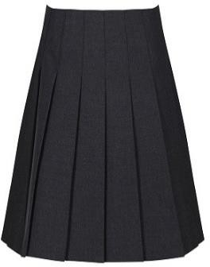 | 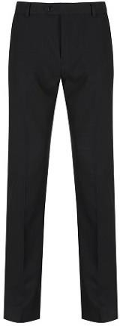 | 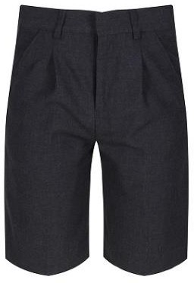 | 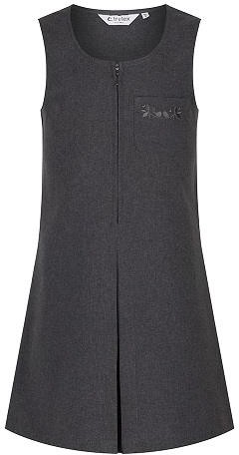
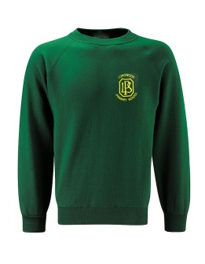 | 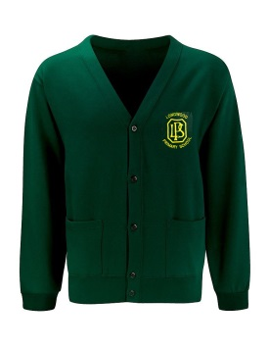 | 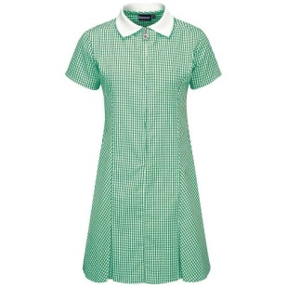
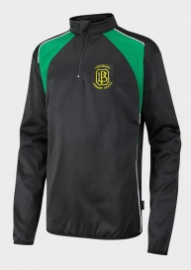 | 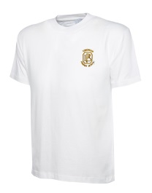 | 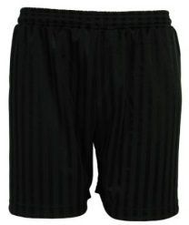
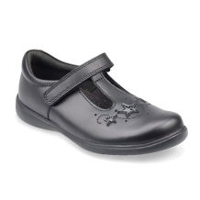 | 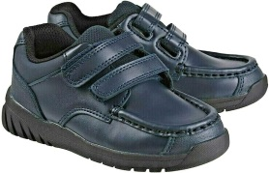 | 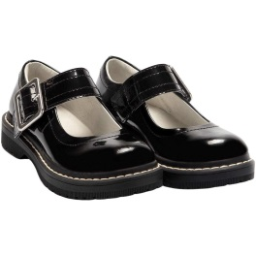 | 