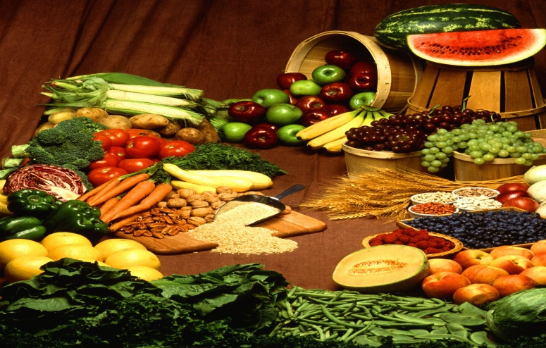
Year 3
Homework Guide
Autumn1
Our family fun homework project this term is based around our theme: Scrumdiddlyumptious!
Please pick any of the following suggestions or you may wish to pick your own project based on our theme.

Project suggestions
- Write a shopping list for your family’s weekly menu and calculate how much it will cost. Don’t forget to look for Fair Trade options.
- Keep a food diary to record the different types of food you eat over the weekend. Report back, in your opinion, has your family got a balanced diet?
- Make an alphabetic list of foods from A to Z. Is it possible?
- Make an information booklet about a festival that involves eating a special type of food. There are lots to choose from!
- Make a dish from a recipe book and take photographs to share back at school. Remember to wash your hands before getting going!
- Write an imaginative story which starts…‘You’re not going to eat me are you?’ said the…
- Make a fabric dye from a strongly coloured fruit or vegetable. Try beetroot, carrots, tea, spinach or strawberries. Try dip-dying an old white T-shirt or handkerchief into your coloured dye… What happens?
- Design and make an exciting sandwich. Bring it in to school for everyone to taste!
- Plan yourself a weekly exercise regime and encourage a parent or carer to do it with you!
Your project needs to be brought into school by the end of the second week to share with the class.
If you have any questions please do not hesitate to ask.

