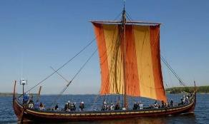

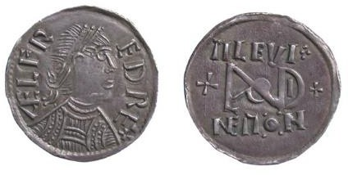
- Visit your local library and find out about any Saxon or Viking invasions in your local area or county.
- Try making some Anglo-Saxon bread or Viking flatbread (search online for recipes).
- Look at King Alfred’s pledge: ‘I desired to live worthily as long as I lived, and to leave after my life, to the men who should
come after me, the memory of me in good works’. Write your own pledge – how would you like to be remembered in the future?
- Look at images of Anglo-Saxon coins. Can you design your own coin? You could draw a picture or use modelling clay or other materials to make your coin look like metal – use
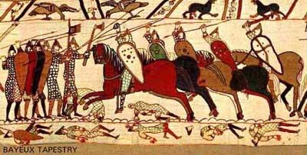
your imagination!
- Do some research about Viking names and their meanings, and make up some suitable Viking names for your friends and family. Remember to describe something about the person’s appearance or characteristics.
- Research some simple Viking embroidery patterns. Using a
needle and coloured threads, embroider a small handkerchief. Maybe you could give it to someone as a present?
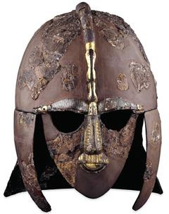
- Look at animals in Viking art (search online for Urnes or Jelling style). Can you design and draw your own imaginary beast to make a fantastic pattern?
- Find out more about the futhark or runic alphabet used by the Vikings. Write a short message using the runic characters. They wrote on wood, bone and stone. What will you use?
- Listen online to someone speaking Old English or Old Norse. Can you
recognise any of the words? Can you learn how to express a greeting or phrase in one of these ancient languages?
- Imagine you are a Viking skald, or poet. Create a poem to sing the praises of a friend or family member.
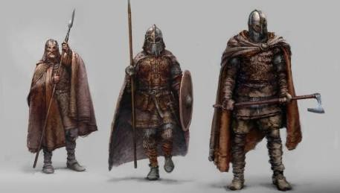
- Dress up in a typical Saxon or Viking costume. Are you a farmer, warrior, child or tradesperson? Red and gold were favourite colours but
poorer people might not be able to afford to dye their cloth.
- Find out about real treasure (often known as hoards) discovered from this period. Sutton Hoo and the Staffordshire Hoard are good examples. You might find information on hoards close to your school. However, exact locations are often kept secret. Can you think why?

