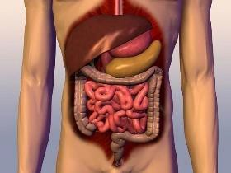

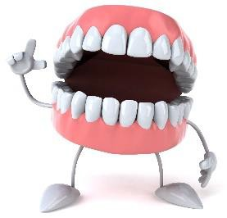
- Keep a food diary and notice what happens as certain foods (like beetroot, sweetcorn, asparagus or blueberries) pass through your body.
- Who spends the most time in the bathroom in your house? Make some observations and display your findings in a graph or chart!
- Find out how to look after your digestive system with some colon-cleansing foods (cider vinegar, flax seeds, avocado and spinach are good) and make a song/poster encouraging people to look after their guts!
- Learn how to boost your immune system. Make a poster or advert for a doctor’s surgery helping people to avoid falling victim to the flu season.
- Do you have any horrid habits (like nail biting, nose or ear picking)? What habits do you dislike in others? Think up some tips on how to give up a horrid habit
- .Have a burping /belching competition with family or friends! Set rules to make it fair. Record the contestants to resolve any disputes and decide whether carbonated (fizzy) drinks are allowed.
- Drop grubby copper-plated coins into a range of fizzy drinks and
leave them overnight to see what happens. Which brand has the most powerful cleaning properties?
- What qualifications and training do you need to become a dentist? You could quiz your dentist at your next check up! Ask before you have a mouthful of instruments!
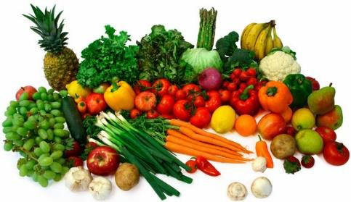
- Some people sneeze because they are allergic to certain substances such as pollen or house dust mites. Survey your friends and family and find out if anyone you know has an allergy. How will you record the information?
- Try a new food or a drink that you have never tasted before. What do you like or dislike about its taste and texture?

